Summer 2019 Student Employment Hiring Guidelines

Table of Contents
Student Employment Eligibility Requirements
Current Students
Work-Study
Student Employment
UNMJobs Hiring
How to Run Active Students Report in HR Reports

Student Employment Eligibility Requirements:

- Students must be admitted in a degree granting college
- Students must meet the required Standards for Academic Progress (Work-study students only)
- Work study students must be enrolled at least half-time (at least 3 credit hours) for the summer
- Students must present documentation for their I-9. I-9 documentation must be submitted by all students who are NEW UNM employees or have had at least a one (1) year break in UNM employment

Summer Work-Study

Financial Aid will begin accepting Summer Financial Aid Request forms today, April 15, 2019. Students must be registered for summer BEFORE submitting their requests. Summer work-study is available on a first-come, first-served basis and limited funds are available. Please encourage your students to register and submit their request form as soon as possible. Forms are available at http://finaid.unm.edu/forms/2018-2019/summer-request.pdf

All spring work study students end on or before 5/11/2019. Work-study students must be enrolled half-time for summer and have a summer work-study award. Before submitting any paperwork to hire a work study student for the summer, please ensure they meet all of the summer work-study requirements. Fall/spring work study awards will not roll over to summer.

Summer Student Employment

Many students who are currently under Student Employment have an open end date. If the end date is blank, you do not need to take any action. However, students must be registered for summer or fall by 7am Monday, April 29th. Student employees who do not register for summer or fall will be administratively separated with an end date of May 10th, 2019.

Please note, student employees and their department will be charged FICA taxes for any period of non-enrollment, including summer.

Summer Positions that require Background Checks

Per UNM Policy #3280 (Background Checks), we are required to conduct a background check for students in "Safety and Security Positions." If you have not posted for your summer program positions, please submit them as soon as possible to ensure that you begin the hire process early. Please keep in mind that it will take additional time to conduct a background check.
Please do not submit any extension ePAFs or transfer ePANs for students until you verify that the student meets the requirements listed for summer work study or summer student employment. Paperwork submitted for students who do not meet the requirements will be denied.

Summer Work-Study

Please verify that your student meets employment eligibility (enrollment, degree status, and work study award, if applicable) prior to submitting any paperwork for a student.

- Please run an HR Report using the instructions below (HR Report Parameters for Current Student Employees). If you do not have access to HR Reports, please check with your Department Administrator or the person who handles HR duties for your department. This report will be used to determine if you need to extend or transfer your current student.
- Use the “Extension/Transfer Guidelines for Current Student Employees” to determine what paperwork, if any, is required for each of your students.

- Current student employees must be enrolled at least half time (at least 6 credit hours) for the spring semester
AND
- Enrolled at least half time for the summer semester (at least 3 credit hours)
- Students must have a work-study award for summer
- All summer work-study assignments end on August 16th
- EPAF extensions and transfer EPANs are used when there is no break of employment. If there is a break of employment, you will need to follow the “UNMJobs Hiring” process
- EPAFs and EPANs must be submitted with future start dates. Backdating will not be accepted

- Please be sure that all paperwork is complete and follows the requirements outlined in UNM Policy #2000.
- If you need to complete an extension EPAF, please be sure to select the position number associated with your org#.
- Submit completed EPANs to our office via email (stuemp@unm.edu).

- The priority date to submit extension EPAFs and Transfer EPANs for current student employees is Monday, April 29, 2019 @ 5pm. Priority will be given to forms/requests submitted by this date. Anything submitted after will be processed on a case by case status in the order received. Therefore, we will not guarantee your current student employee may continue working past their current job end date. Please check your HR Reports before allowing students to continue working.
Summer Student Employment

Please verify that your student meets employment eligibility (enrollment, degree status, and work study award, if applicable) prior to submitting any paperwork for a student.

- Please run an HR Report using the instructions below (HR Report Parameters for Current Student Employees). If you do not have access to HR Reports, please check with your Department Administrator or the person who handles HR duties for your department. This report will be used to determine if you need to extend or transfer your current student.
- Use the “Extension/Transfer Guidelines for Current Student Employees” to determine what paperwork, if any, is required for each of your students.

- Current student employees must be enrolled at least half time (at least 6 credit hours) for the spring semester
AND
- Enrolled at least half time for the summer semester (at least 3 credit hours) OR pre-enrolled at least half-time (6 credit hours) for the fall semester

- If a student employee (UB) has an open end date, you do not need to take any action unless you want to transfer them to work-study for the summer, if the student is awarded.
- EPAF extensions and transfer EPANs are used when there is no break of employment. If there is a break of employment, you will need to follow the “UNMJobs Hiring” process
- EPAFs and EPANs must be submitted with future start dates. Backdating will not be accepted

- Please be sure that all paperwork is complete and follows the requirements outlined in UNM Policy #2000.
- If you need to complete an extension EPAF, please be sure to select the position number associated with your org#.
- Submit completed EPANs to our office via email (stuemp@unm.edu).

- The priority date to submit extension EPAFs and Transfer EPANs for current student employees is Monday, April 29, 2019 @ 5pm. Priority will be given to forms/requests submitted by this date. Anything submitted after will be processed on a case by case status in the order received. Therefore, we will not guarantee your current student employee may continue working past their current job end date. Please check your HR Reports before allowing students to continue working.
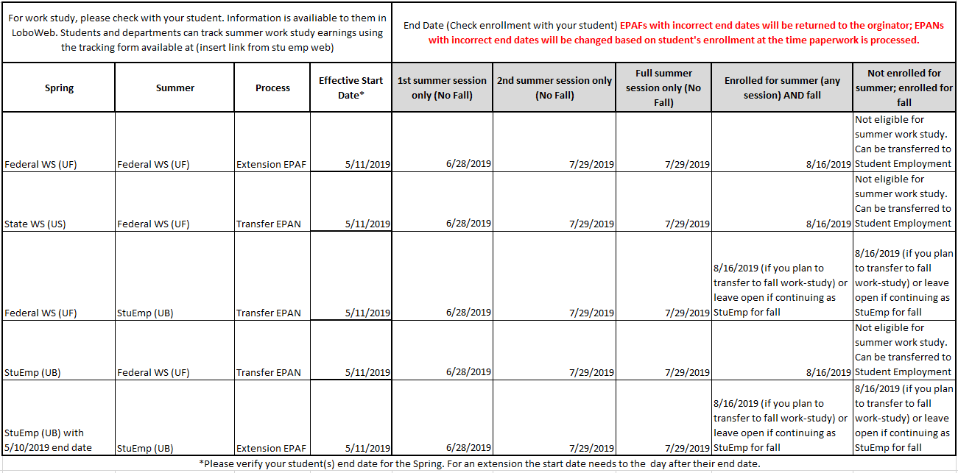
Summer 2019 Extension/Transfer Guidelines (Spring to Summer)

UNMJobs Hiring Process
Please verify that your student meets employment eligibility (enrollment, degree status, and work study award, if applicable) prior to submitting any paperwork for a student.
Use the UNMJobs Hiring process for Summer New Hires, Promotions, Add Jobs (2nd and 3rd jobs), and Returning Students with a break of employment of 180+ days.
Requisitions (Reqs)
We encourage you to submit requisitions as early as possible to allow for more posting time. Please be sure to follow the SOPs in the Student Recruiting Resources in the Career Center and ensure you submit a complete requisition to reduce errors.
The priority date to submit summer requisitions is Monday, April 22, 2019 @ 5 pm. Requisitions submitted after this date will be processed in the order received. However, we cannot guarantee that you will have enough time to hire student employee(s) with a May 13th, 2019 start date.

Hiring Requests
Reminders:
- Initial “Offer Letter” notifications will be sent to student employees who must submit documentation/forms such I-9, add job or FTE memos, background checks, etc
- Initial “Offer Letter” notifications will NOT be sent to student employees who are getting promotions or returning students with a valid I-9 form on file and are not required to submit documentation
- “Authorization to Start Working” emails will be sent to ALL students when their employment eligibility is verified. These emails will state the student’s approved start date. Hiring managers and supervisors as indicated on the requisition will be CC’d on this email.

- The priority date to submit hiring requests for UNMJobs student employees is Wednesday, May 1, 2019 @ 5pm.

- In order to begin working on May 13th, students must complete their required paperwork by Friday, May 3, 2019 @ 5pm.

- Priority will be given to requests submitted by these dates. Anything submitted after will be processed in the order received. Therefore, we will not guarantee your new student employee may begin working on May 13, 2019.
- Please be sure that all paperwork is complete and follows requirements outlined in UNM Policy #2000. The turnaround time increases if we receive requisitions or Hiring Requests with errors or missing information.

Please note the following:

  - Students should expect to spend at least 20 minutes completing documents while at the Student Employment Office.

  - Documents for the I-9 form must be original and unexpired. A list of acceptable documents is available below.

  - After your student completes all hiring documents at our office, the Hiring Manager, supervisor, and student will receive a final “Authorization to Start Working” email with an attached letter indicating their approved start date.

***Please do not allow students to begin working until this notification is received. Allowing students to work prior to their start date will cause problems with student’s pay and is in violation of federal regulations.

  - Once they have their Student Employee Life tab in LoboWeb, students must follow the instructions in the “Authorization to Start Working” letter to complete their W-4 form, direct deposit information, etc.
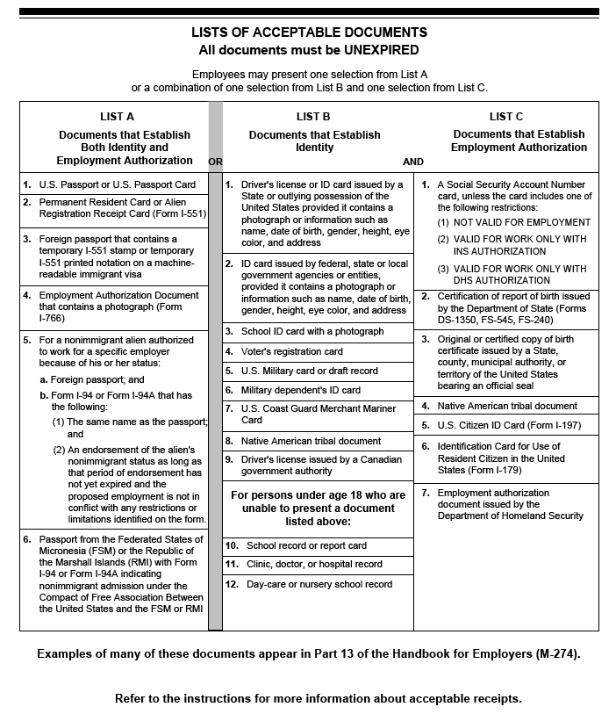

How to Run HR Reports by Date Range:

- On the main HR Reports page, go to Employee Application
- Select: Employees by Date Range
  - Under “Select Criteria”: “Select by Level 3 Org”
  - Select your Level 3 Org
  - Select: Org(s)
  - Begin Date: enter the begin date of your search
  - End Date: enter the end date of your search
  - Run Report

- Select Action and Filter
  - In the Filter (defaults to column), select the following:
    - Column: eClass
    - Operator: =
    - Expression: UB
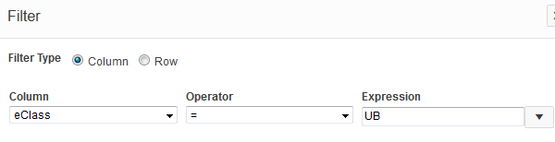
  - Apply

- Under Actions, select “Select Columns”
  - Under “Display in Report”, keep the following (this is the order we use, but you can put them in any order):
    - Org, UNM ID, Name, Position, Suffix, Job Title, eClass, Hourly Rate, Supervisor, Appt%, Job Begin Date, Job End Date, Job Status, Job Change Reason, Job Change Reason Description
  - Apply
  - Go to Actions, 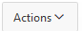 then Download
  - Click on Excel download Icon
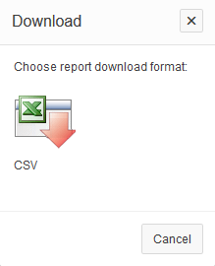
  - Open downloaded file
  - Under the Home Tab, go to Sort & Filter under Editing (on the far right of the page)
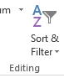
  - Select “Custom Sort”
  - Under Sort by Column, select “Name”
  - Click Add Level
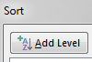
  - Select “Job End Date” under Sort by Column; order should be “Oldest to Newest”
