Student Employment Hiring Process

Congratulations the hard part is over! You’ve been hired! But Wait! There are a few things you need to complete before you can begin working!
- You’ve applied for a job on the UNMJobs website and have been hired. You now have to wait for your department to submit a hiring request to Student Employment.
- You will ONLY receive an initial “Offer Letter” from UNM Jobs if you need to complete any paperwork at the Student Employment office.

DO NOT begin working.
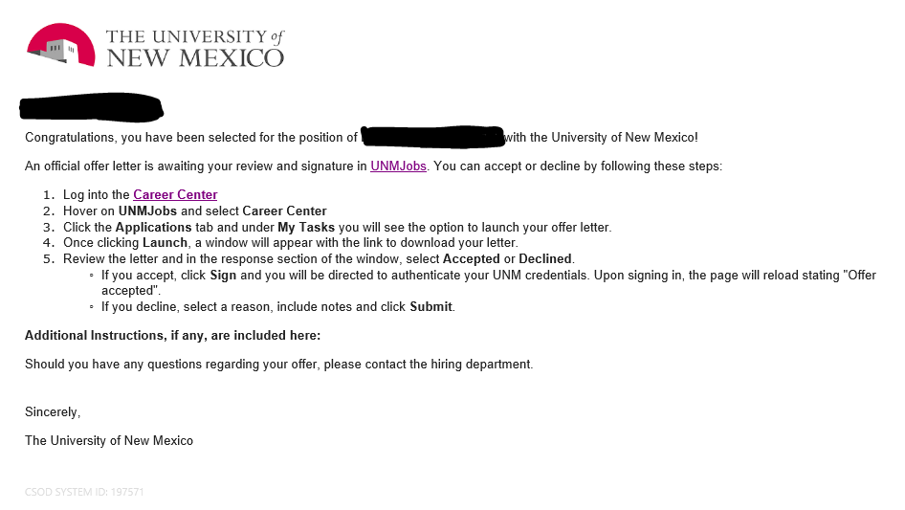
- If you receive the initial “Offer Letter” you need to go to the Student Employment office. (Go to Step 4 to know what documents you can bring to fill out your I9, if needed.)
*If you did not receive the initial “Offer Letter” that is because you have a current I9 on file with Student Employment and you are not required to complete any documents or forms. However, you may not begin working until you receive an Authorization to Start Working email. That email will provide you with your official start date.*
- Next step is to fill out your I9 form if this is the first time working at UNM or if you have had a break in employment at UNM longer than a 1 year per school policy.
  - On page 4 of the link, there is a list of the acceptable document(s) that you may present original and unexpired documents of.
  - DO NOT begin working.
- Once your I9 forms are completed we will send you onboarding tasks that you need to complete.
  - If you set up your UNM Jobs account “internally” with your UNM email. Please go to unmjobs.unm.edu
    - Click on the blue box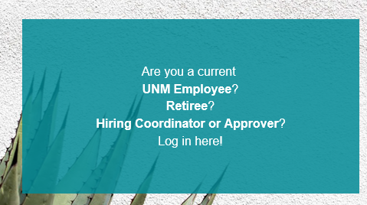
    - Login using your UNM email credentials
    - Complete “Onboarding Tasks” that are located in the top right corner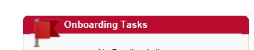
    - DO NOT start working
  - If you set up your UNM Jobs account with an “external” email such as Gmail, Yahoo, AOL, etc. Please use unm.csod.com.
    - Login using your external profile credentials
    - Complete “Onboarding Tasks” that are located in the top right corner
  - Once you have completed these onboarding tasks give us a call (505) 277 -3511 or send us an email (Stuemp@unm.edu) to verify that the forms went through and were completed properly.
      - If you already have one job at UNM and you are adding another position, you will need to bring a completed and signed 2 Job Memo to the Student Employment Office.
      - If you already have two jobs at UNM and you are adding another position, you will need to bring a completed and signed 3 Job Memo to the Student Employment Office.
      - If you have a Graduate position, you will need to bring a completed and signed FTE Memo to the Student Employment Office.
- Once these are completed you will receive an Authorization to Start Working email, providing you with your official start date.
- For scheduling details contact your supervisor.
- Have a great first day and time at your new job here at UNM! Go Lobos!
If you have any questions or concerns please call us at 505-277-3511 or email stuemp@unm.edu. We are open 8-5 Monday thru Friday.

