Run HR Report to determine the students you need to extend or transfer:

- On the main HR Reports page, go to Employee Application
- Select: Employees by Date Range
  - For Select Criteria: “Select by Level 3 Org”
  - select your Level 3 Org
  - Select: Org(s)
  - Begin Date: Select 05/01/2017 (you can select 05/12/2017 but if you have students who ended earlier then they will not show up on your report)
  - End Date: 08/31/2017
  - Run Report

- Select Action and Filter
  - In the Filter (defaults to column), select the following:
    - Column: eClass
    - Operator: =
    - Expression: UB
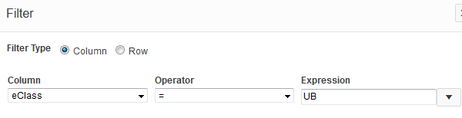
  - Apply

- Under Actions, select “Select Columns”
  - Under “Display in Report”, keep the following (this is the order I use but you can put them in any order):
    - Org, UNM ID, Name, Position, Suffix, Job Title, eClass, Hourly Rate, Supervisor, Appt%, Job Begin Date, Job End Date, Job Status, Job Change Reason, Job Change Reason Description
  - Apply
  - Go to Actions, 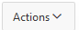 then Download
  - Click on Excel download Icon
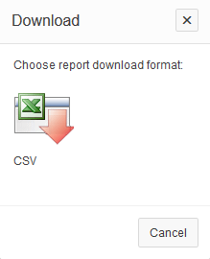
  - Open downloaded file
  - Under the Home Tab, go to Sort & Filter under Editing 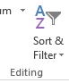 (on the far right of the page)
  - Select “Custom Sort”
  - Under Sort by Column, select “Name”
  - Click Add Level 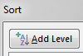
  - Select “Job End Date” under Sort by Column; order should be “Oldest to Newest”
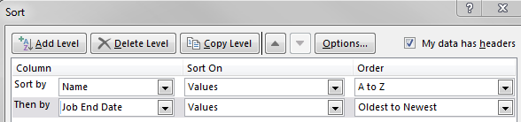

  - Students with end dates of 5/12/17 will need to be extended or transferred by your department by May 1, 2017 in order to work during the 2R11 pay period (5/13/17-5/26/17).

