Student Employment: How to Check or Update your W4 Tax Form

Revision Date: 04/09/2019
Responsible Department: Student Employment Office

Step # | Action/Field Name
1 | Log into: my.unm.edu
2 | click on your Student Employment tab  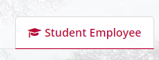
3 | If you do not have this tab please click on the + sign and add the Student Employment tab (more in-depth instructions in you Authorization Letter that was sent to you via email)
4 | Click on Enter Loboweb  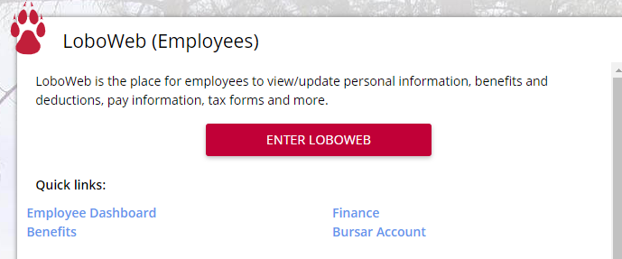
5 | Be sure you are in the Employee tab  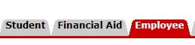
6 | Click on Tax Forms  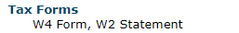
7 | You will be directed to the Duo 2 factor authentication page. Click on Continue  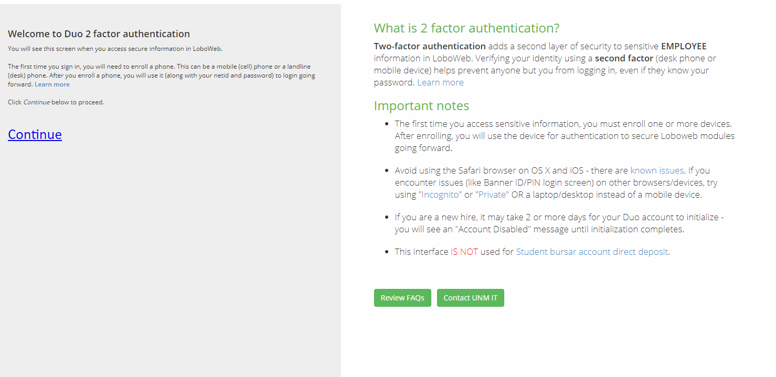
8 | Login
9 | Click “call me” it is faster than the “enter a passcode” selection and follow the voice instructions on the line.  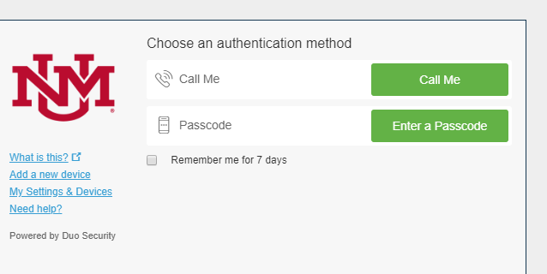
10 | Click on Federal Tax Exemptions or Allowances (W4)
11 | You do not to make any changes here. Please just verify if everything is correct and accurate.
12 | If changes need to be made select update at the bottom of the screen and proceed to make the corrections and then click save.  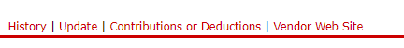
13 | Exit out of the screen and you are good to go.

Please call 505-277-3511 for any questions.

