Student Employment: How to Set Up or Change your Direct Deposit

Revision Date: 04/09/2019
Responsible Department: Student Employment Office

You will need your Routing Number and Account Number
Please contact your bank to access these numbers

Step # | Action/Field Name
1 | Log into: my.unm.edu
2 | Click on your Student Employment tab  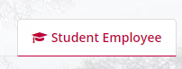
3 | If you do not have this tab please click on the + sign and add the Student Employment tab (more in-depth instructions in you Authorization Letter that was sent to you via email)
4 | Click on Enter Loboweb  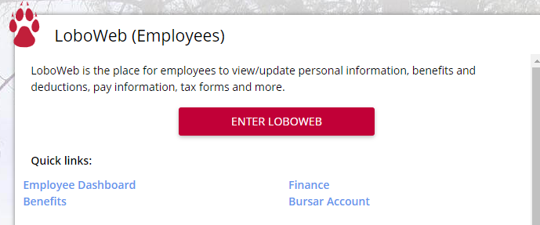
5 | Be sure you are in the Employee tab  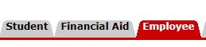
6 | Click on Pay Information
7 | Select on Direct Deposit Allocation
8 | You will be directed to the Duo 2 factor authentication page. Click on Continue  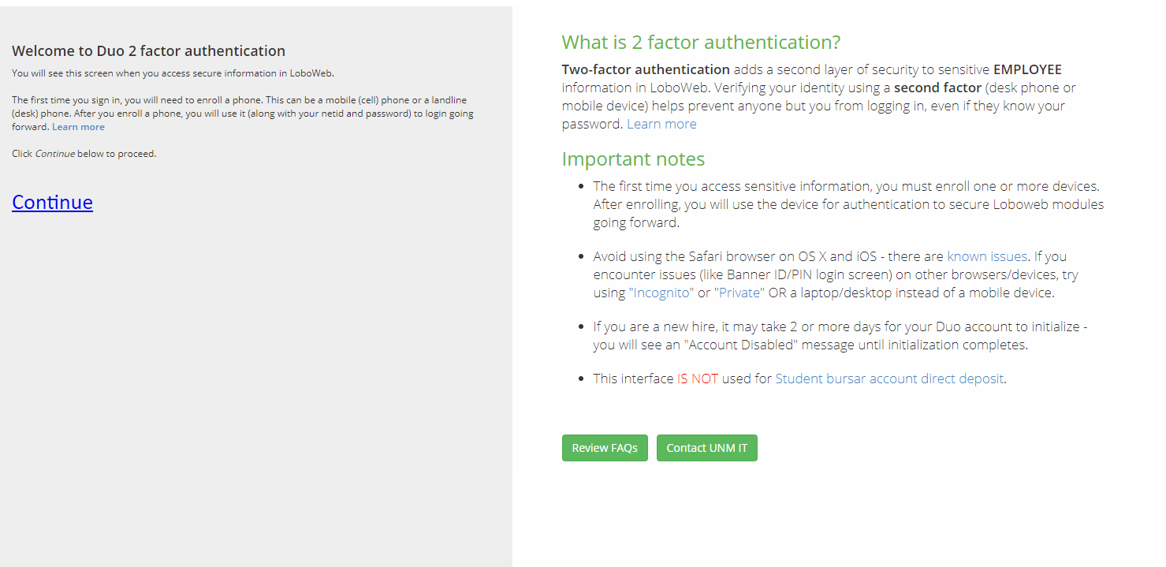
9 | Login
10 | Click “call me” it is faster than the “enter a passcode” selection and follow the voice instructions on the line.  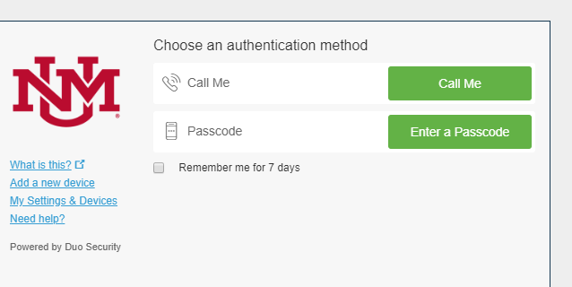
11 | Here is where you will set up your direct deposit or update it.
12 | You will need your Routing Number and Account Number
13 | Enter the information and click save once everything is correct  The allocation % is the amount of your paycheck you want to go to this account. If you want to split your check in half and put half in your checking account and half in your savings, for example, this is the place to do that.  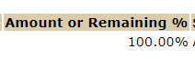
14 | Click save
15 | Exit out of the screen and you are good to go!  Your next paycheck will be deposited into the account you set up.

Please call 505-277-3511 for any questions.

